**Visit our website at:** [**www.healingfield.org/flagstaff18**](http://www.healingfield.org/flagstaff18)

**February 24th - 26th**

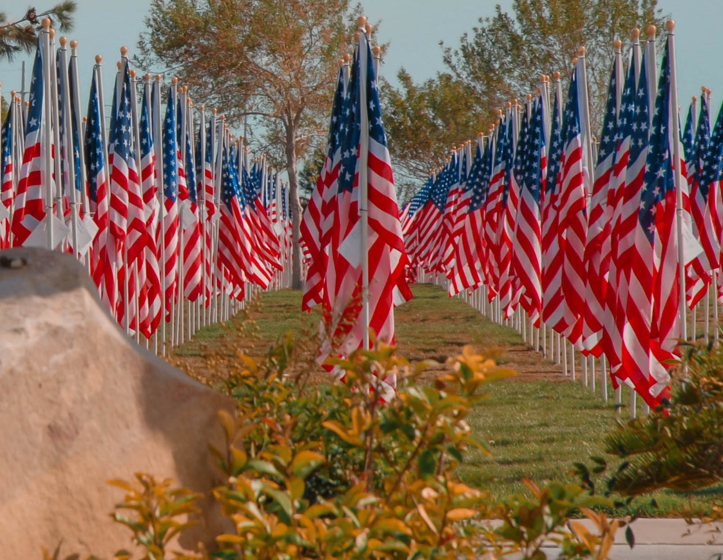

The Rotary Club of Jurupa Valley is pleased to present the First Annual Field

of Honor®, where members of the community can honor their heroes with an American Flag. Hundreds of flags will be on display in perfect rows for public viewing 24 hours a day during the event. Flags can be purchased in memory

or honor

Proceeds

of service members, past and present, regardless of where ty live.

from the Field of Honor® will benefit the Veterans memorial Park.

**VETERANS MEMORIAL PARK**

2827 South Military Rd

Flagstaff, AZ 84707